Amazon Sales Analysis Report
Comprehensive Sales Analytics

Performance Metrics
Total Sales Total Profit Total ORDERS Total Customers
$1.57M $175.26K 5,901 773

Payment & Shipping Analysis
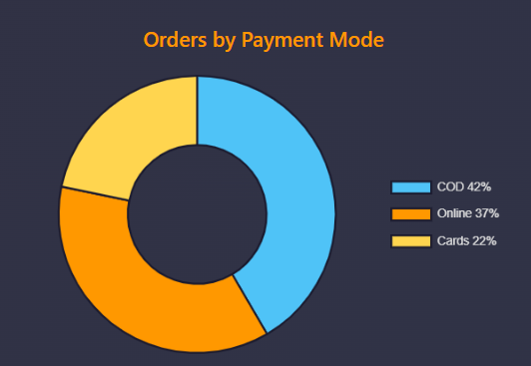
Analysis: Cash on Delivery (COD) dominates the payment landscape at 42%, indicating customers prefer to pay upon receiving their products. Online payments account for 37%, showing growing digital adoption. Card payments at 22% suggest room for growth in digital payment methods.

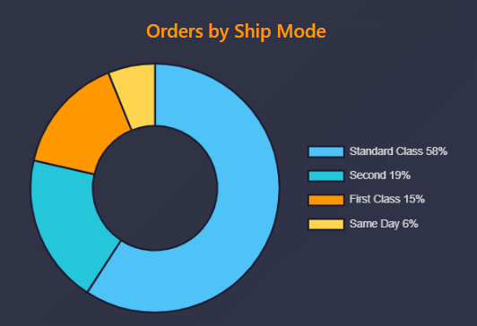
Analysis: Standard Class shipping is the overwhelming favourite at 58%, demonstrating that customers prioritize cost-effectiveness over speed. Same Day delivery at only 0% indicates either limited availability or premium pricing that restricts widespread adoption.

Customer Segmentation Analysis
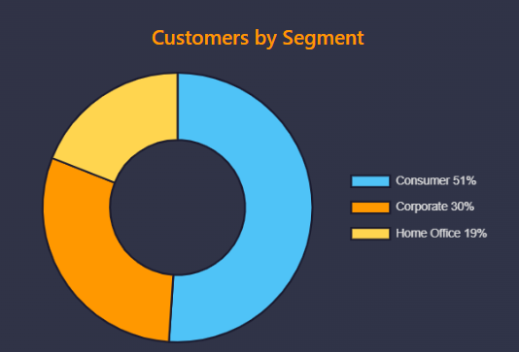
Analysis: The Consumer segment leads with 51% representing the largest portion of the customer base and indicating strong B2C market presence. Corporate customers at 30% show significant business-to-business opportunities. Home Office segment at 19% reflects the growing trend of remote work and small business operations. This balanced distribution across segments demonstrates diversified revenue streams and reduced dependency on any single customer type.
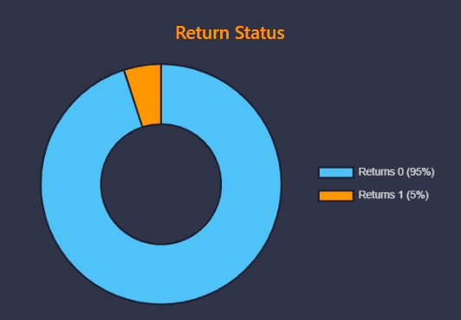

Analysis: An impressive 95% success rate (Returns 0) demonstrates exceptional product quality, accurate descriptions, and reliable fulfilment processes. Only 5% returns (Returns 1) indicate high customer satisfaction and proper order management. This low return rate reduces operational costs, minimizes reverse logistics expenses, and enhances profitability.

Category & Sub-Category Analysis
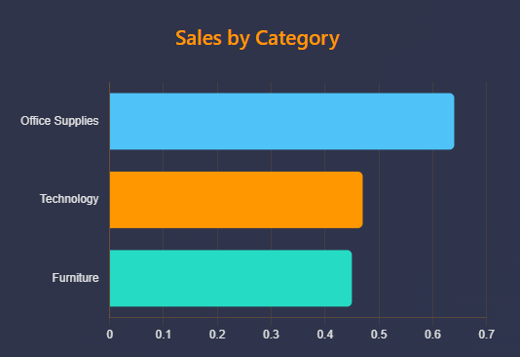

Analysis: Office Supplies leads the category performance with $0.64M in sales, representing the highest revenue generator. This dominance suggests strong demand for consumables and workplace essentials. Technology followed at $0.47M, indicating substantial profit opportunities and high-tech trends. Furniture at $0.45M shows competitive performance. The relatively balanced distribution demonstrates a well-diversified product portfolio.

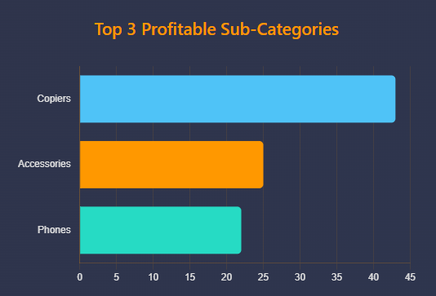

Analysis: Copiers emerge as the most profitable sub-category, generating $43K, nearly double the next category. This high profitability suggests premium pricing and strong margins on business equipment. Accessories at $25K show steady performance, benefiting from high-volume, repeat purchases. Phones at $22K demonstrate consistent demand in the technology segment.

Quarterly Performance Analysis
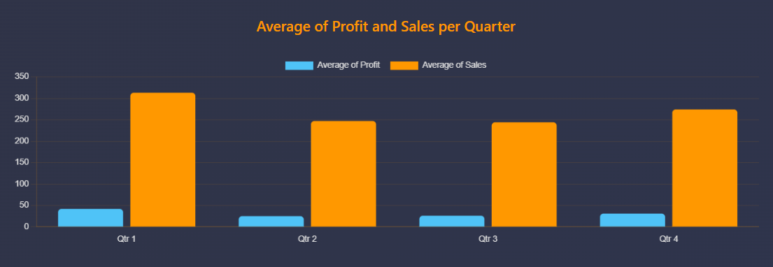

Analysis: Q1 stands out as the strongest performing quarter with the highest profit (42) and sales (313), possibly driven by post-holiday shopping and new year purchases. Q4 shows recovery with profit of 31 and sales of 274, likely boosted by holiday season demand. Q2 and Q3 show relatively stable but lower performance (Q2: 25 profit, 247 sales; Q3: 26 profit, 244 sales), suggesting seasonal patterns. The profit-to-sales ratio remains consistent across quarters, indicating stable operational efficiency. This trend suggests opportunities for targeted marketing campaigns during slower quarters to balance annual performance.

Monthly Sales Trends
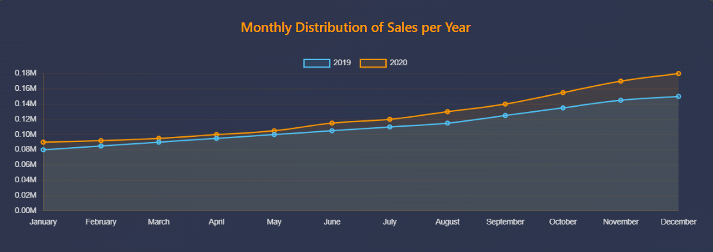

Analysis: The monthly trend analysis reveals consistent upward growth throughout both 2019 and 2020. Sales started at approximately $0.09M in January 2019 and climbed steadily to $0.15M by December 2019. The 2020 performance shows acceleration, reaching $0.18M by December, indicating a 20% improvement over 2019. Both years show seasonal patterns with gradual increases through the year, peaking in Q4. The consistent upward trajectory demonstrates business resilience and market demand strength.

Executive Summary - Key Insights
- Cash on Delivery remains the preferred payment method at 42%, indicating strong customer trust in the delivery system.
- Standard Class shipping dominates with 58% market share, suggesting customers prioritize cost over speed.
- Q1 shows exceptional performance with the highest profit margin (42) and sales (313).
- Office Supplies leads category sales at $0.64M, followed by Technology at $0.47M.
- Copiers emerge as the most profitable sub-category generating $43K in profits.
- Consumer segment represents over half of the customer base (51%), highlighting B2C market strength.
- Excellent customer satisfaction with 95% successful order completion rate.
- Year-over-year growth from 2019 to 2020 shows 20% improvement, demonstrating business resilience.

